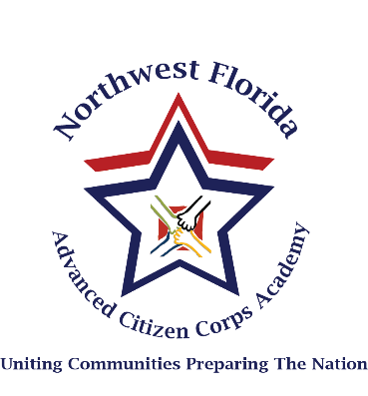

Northwest Florida Advanced Citizen Corps Academy

Friday, September 25th, 2020
Time | Activity | Location | Instructors
1500 – 1600 | Check in and registration at PSB | Hotels/ PSB
1600 – 1630 | Introductions and Expectations | Rooms  PSB | All
1630 – 1800 | Disaster Psychology | Room | Amie Readdy
1630 – 1800 | Cybersecurity | Room | Stephanie Cassidy
1630 – 1800 | Stop the Bleed | Room | Tom Lloyd
1815 – 1945 | Active Shooter Exercise | Room | Santa Rosa EM  (Law Enforcement Pending)

Saturday, September 26th, 2020
Time | Activity | Location | Instructors/Participants
0700 – 1100 | Wilderness First Aid (Part 1) | Room 1 | Steve Samaha
0700 – 0900 | The Role of the Faith-based Community After a Disaster | Room | Dennis Harris
0910 – 1110 | Stop the Bleed | Room | Tom Lloyd
0910 – 1110 | HAM Radio Training | Room | Roy Wilkinson (Escambia EM)
0910 – 1110 | Disabilities and Functional Needs Panel | Room | Mary Lynn Williams, Grace McCaffery, Maralee Sartain,  Mike Martin,  Pastor Michael Collins, John Connell
1120 – 1230 | Lunch | Rooms

1245 - 1645 | Wilderness First Aid (Part 2) | Room | Steve Samaha
1245 – 1445 | Basic Storm Spotter/ zoom or video | Room/zoom | Jason Beaman
1245 – 1445 | Protection in disaster response during COVID | Room | Ron Toole
1245 – 1645 | Shelter Fundamentals- videos? | Room/zoom | Red Cross- Zoom
1500-1700 | Helicopter Landing Zone | OUTSIDE | Tom Lloyd
1645 – 1830 | Dinner | Off Campus
1845 – 2030 | Night Exercise  Search and Rescue | Outside/video | ESAR  Jim Walters

Sunday, September 27th, 2020
Time | Activity | Location | Instructors/Participants
0745 – 0945 | Responder Rehab/Field exercise | Public Safety Field | Santa Rosa EM
1000 – 1200 | After Action Review/  Commencement |  | BRACE/Santa Rosa EM

